**Gym-Trainer: Correct Posture Detection during exercise**

# Roadmap

1. **Our Approach to Creating a Posture Detection Model for Exercise Videos**

Creating a posture detection model for exercise videos with labeled data (0 for incorrect posture and 1 for correct posture) is a multi-step process. Here's our general approach to training such a model:

**Data Collection and Preprocessing:**

* We collected a diverse dataset of exercise videos, with labeled annotations indicating whether the posture is correct or incorrect.
* We split our dataset into training, validation, and testing subsets to evaluate the model's performance.

**Feature Extraction:**

* We utilized a human pose estimation library like MediaPipe or OpenPose to extract key body joint landmarks from each frame of the video.
* Each frame was represented as a set of feature vectors, with each vector corresponding to a landmark.

**Temporal Sequencing:**

* Recognizing that videos are sequences of frames, we organized the feature vectors in a way that preserved the temporal order. This involved creating sequences of feature vectors for each video.

**Data Augmentation:**

* We applied data augmentation techniques to introduce variability and enhance the model's ability to generalize. For video data, this included random cropping, flipping, and adjusting brightness or contrast.

**Model Selection:**

* We carefully selected an appropriate deep learning architecture for our task. Popular choices included 3D CNNs, RNNs (e.g., LSTM or GRU), or combination models that incorporated both spatial and temporal information.

**Model Architecture:**

* We designed the model architecture to accept sequences of feature vectors and produce binary classifications (correct or incorrect posture).
* Pre-trained models for pose estimation were used as feature extractors, with additional layers added for classification.

**Loss Function and Metrics:**

* We chose an appropriate loss function, such as binary cross-entropy, for our binary classification task.
* Throughout training and testing, we relied on evaluation metrics like accuracy, precision, recall, F1-score, and ROC-AUC to assess model performance.

**Training:**

* We trained our model on the training dataset, which consisted of labeled sequences of feature vectors.
* To prevent overfitting, we implemented techniques like early stopping and learning rate scheduling.

**Validation:**

* We closely monitored the model's performance on the validation dataset during training, making adjustments as needed to avoid overfitting.

**Testing:**

* The trained model was evaluated on the test dataset to assess its generalization performance.

**Fine-tuning and Optimization:**

* As necessary, we fine-tuned hyperparameters and model architecture to improve performance.
* We also considered strategies for handling class imbalance, especially as one class (e.g., correct posture) might dominate the dataset.

**Deployment:**

* Once we were satisfied with the model's performance, we deployed it to make real-time predictions on new exercise videos.

**Continuous Improvement:**

* We recognized the importance of regularly updating and retraining our model with new data to maintain accuracy and relevance.

It's important to note that creating an effective posture detection model may require a significant amount of labeled data, and the model's performance depends on the quality and diversity of the dataset. Additionally, ongoing monitoring and refinement of the model are necessary to adapt to different exercises and variations in posture.

# Data Collection and Preprocessing

## Data Collection for Our Single Exercise Posture Detection Model

When collecting data for our single exercise posture detection model, we streamlined the process to suit our specific needs. Here are the considerations tailored to this focused data collection effort:

**1. Exercise Variation:**

We collected videos of the same exercise performed by different individuals with varying levels of expertise. This diverse dataset helps our model generalize across different body types and execution styles.

**2. Multiple Repetitions:**

We ensured that each video captured multiple repetitions of the exercise. This approach allowed us to capture variations in form throughout the movement, enhancing the richness of our dataset.

**3. Correct vs. Incorrect Examples:**

We maintained a balanced dataset that includes examples of both correct and incorrect executions of the exercise. This balance is crucial for training a reliable posture detection model.

**4. Fixed Camera Placement:**

Since our camera position is fixed in one direction, we experimented with this fixed angle to capture the exercise from different perspectives and angles, when applicable.

**5. Exercise Duration:**

We considered the duration of the exercise in our videos. Longer exercises may necessitate additional storage space and present challenges during the annotation process.

**6. Data Annotation:**

We annotated each video with labels indicating whether each repetition of the exercise is correct or incorrect. We ensured that this annotation task was carried out accurately by experts or individuals with relevant knowledge.

**7. Consistency in Recording:**

We maintained consistency in the recording environment. We paid attention to factors such as lighting conditions and camera settings to minimize variability unrelated to posture.

**8. Feedback from Participants (If Feasible):**

If possible, we gathered feedback from participants who performed the exercise. Their insights helped us understand their experiences and ensure the clarity of exercise instructions.

**9. Data Storage and Management:**

We organized our dataset efficiently, especially since we anticipated collecting a large number of videos. We implemented clear naming conventions and folder structures to facilitate data management.

**10. Data Validation:** - We regularly validated the quality of the collected data. If necessary, we re-annotated videos and removed noisy or unusable samples to maintain data quality.

**11. User Privacy and Consent:** - We prioritized user privacy by ensuring that participants provided informed consent for the recording and use of their data. We respected their privacy rights throughout the data collection process.

**12. Ethical Considerations:** - We remained mindful of ethical considerations associated with data collection. We protected the identities of participants and adhered to relevant privacy regulations.

By focusing on these considerations and paying attention to the details of our data collection, annotation, and feedback, we created a dataset that is well-suited for training a posture detection model tailored specifically to our chosen exercise.

**Template of data storage in spreadsheet**

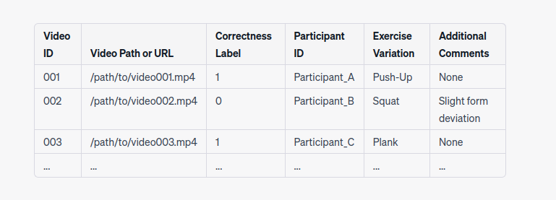

**Work done after midterm**

1. Extracting the features from media pipe and storing them in .npy file
2. Applying data augmentation by removing similar frames and clubbing disimilar frames on FPS (30 fps) in our scale.
3. Applying conventional ML algorithms.

# List of Experiments

1. Decision Tree
2. Random Forests
3. SVM Classifer
4. XGBoost Classifer